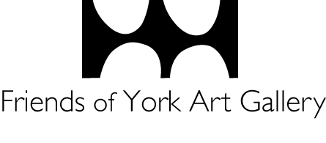
TO ALL MEMBERS OF THE FRIENDS OF YORK ART GALLERY
Do you want to make a difference for fellow Friends and focus your energy in support of the Gallery? Do you know someone who might be interested?

This is an exciting opportunity to use your experience and skills to support the Friends’ ambitious plans in the challenging years ahead. Nominations are particularly welcome from individuals experienced in digital, design, membership and fundraising.

We have identified the following vacancies on the Friends Committee:
- Treasurer
- Secretary
- Membership Secretary
- At least 4 x Trustee positions

Every member of the Friends of York Art Gallery is entitled to nominate any member(s) to be part of the Committee. At present, we have five co-opted members (Benjamin Hilliam, Paul McLean, Moira Fulton and Margaret May), who will retire at the AGM and will stand for election.

In this unique time, we have temporarily adapted our nomination procedure. A Proposer can digitally complete the opposite form and email it to the Secretary, with the Seconder and Nominee copied in. The Secretary will then confirm the support of the Seconder and Nominee via email. Alternatively, a hardcopy of the form can be submitted by following the details opposite. In the event of there being more nominations than available places on the Committee, a ballot will be held during the online Annual General Meeting.

If you wish to become a Committee member but do not have a Proposer or Seconder, please contact me

Benjamin Hilliam
Secretary (Interim)

COMMITTEE MEMBER NOMINATION FORM 2021
Date: ……..………………………………………………………

I wish to propose …………………………………….. to serve on the Committee of the Friends of York Art Gallery as a (delete as appropriate):
- Elected Member
- Secretary
- Treasurer
- Membership Secretary

Name of Proposer: ……..………………………………………………………

Name of Seconder: ……..………………………………………………………

Nominee’s Contact Details:
Email: ……..………………………………………………………

Address and postcode: ……..………………………………………………………

Telephone number: ……..………………………………………………………

(This can be sent as a separate document if more convenient)

Please return the completed form by 19 March 2021 by either emailing (preferred) the scanned form to: secretary@friendsofyorkartgallery.co.uk or to Benjamin Hilliam, Secretary (Interim), Friends of York Art Gallery, York Art Gallery, Exhibition Square, York, YO1 7EW.

